UNITED STATES
SECURITIES AND EXCHANGE COMMISSION
Washington, D.C. 20549
_____________________________________________
FORM 8-K
_____________________________________________
CURRENT REPORT
Pursuant to Section 13 or 15(d)
of the Securities Exchange Act of 1934
Date of Report (Date of earliest event reported): June 1, 2026
_____________________________________________
GRAIL, Inc.
(Exact Name of Registrant as Specified in Charter)
___________________________________________
Delaware |  |  | 001-42045 |  |  | 86-3673636
(State or Other Jurisdiction  of Incorporation) |  |  | (Commission  File Number) |  |  | (IRS Employer  Identification No.)
1525 O’Brien Drive Menlo Park, California 94025
(Address of Principal Executive Offices) (Zip Code)

Registrant’s telephone number, including area code: (833) 694-2553

Not Applicable
(Former Name or Former Address, if Changed Since Last Report)
___________________________________________
Check the appropriate box below if the Form 8-K filing is intended to simultaneously satisfy the filing obligation of the registrant under any of the following provisions:
☐ |  |  | Written communications pursuant to Rule 425 under the Securities Act (17 CFR 230.425)
☐ |  |  | Soliciting material pursuant to Rule 14a-12 under the Exchange Act (17 CFR 240.14a-12)
☐ |  |  | Pre-commencement communications pursuant to Rule 14d-2(b) under the Exchange Act (17 CFR 240.14d-2(b))
☐ |  |  | Pre-commencement communications pursuant to Rule 13e-4(c) under the Exchange Act (17 CFR 240.13e-4(c))
Securities registered pursuant to Section 12(b) of the Act:
Title of each class |  |  |  |  |  | Trading  Symbol(s) |  |  |  |  |  | Name of each exchange  on which registered
Common Stock, par value $0.001 per share |  |  |  |  |  | GRAL |  |  |  |  |  | The Nasdaq Global Select Market
Indicate by check mark whether the registrant is an emerging growth company as defined in Rule 405 of the Securities Act of 1933 (§ 230.405 of this chapter) or Rule 12b-2 of the Securities Exchange Act of 1934 (§ 240.12b-2 of this chapter).
Emerging growth company ☒
If an emerging growth company, indicate by check mark if the registrant has elected not to use the extended transition period for complying with any new or revised financial accounting standards provided pursuant to Section 13(a) of the Exchange Act. ☒

Item 5.02 |  |  | Departure of Directors or Certain Officers; Election of Directors; Appointment of Certain Officers; Compensatory Arrangements of Certain Officers
In connection with Dr. Joshua Ofman’s appointment as the Chief Executive Officer of GRAIL, Inc. (the “Company”), on June 1, 2026, the Company’s board of directors (the “Board”) approved an amended and restated offer letter (the “Amended Offer Letter”) and authorized and directed the Company to enter into such Amended Offer Letter with Dr. Ofman, with the Amended Offer Letter effective as of June 1, 2026 (the “Effective Date”). The Amended Offer Letter supersedes and replaces Dr. Ofman’s existing offer letter. Pursuant to the Amended Offer Letter, Dr. Ofman will serve as the Company’s principal executive officer commencing on the Effective Date.
The Amended Offer Letter provides that Dr. Ofman will receive an annual base salary initially set at $800,000 and will continue to be eligible to participate in the Company’s Variable Compensation Plan (the “VCP”), with a target, from and after the Effective Date, equal to 100% of his annual base salary (his prior VCP target of 60% will continue to apply for the portion of calendar year 2026 preceding the Effective Date). Dr. Ofman will also continue to be eligible to participate in the Company’s health and welfare benefit programs generally available to its senior executives. As soon as reasonably practicable following the Effective Date, the Company will grant Dr. Ofman an award of restricted stock units (“RSUs”) with an aggregate grant date value of $2,000,000, vesting in equal annual installments on each of the first four anniversaries of May 31, 2026, subject to his continued employment through the applicable vesting date.
The Amended Offer Letter provides that if, during the period commencing 3 months prior to, and ending 24 months following the consummation of a Change in Control (as defined in the Company’s 2024 Incentive Award Plan) (the “CIC Period”), the Company terminates Dr. Ofman’s employment without Cause (as defined in the Amended Offer Letter) (other than as a result of his death or disability) or Dr. Ofman resigns for Good Reason (as defined in the Amended Offer Letter), then, subject to his execution of an effective release of claims and continued compliance with applicable restrictive covenants, in addition to accrued amounts (including any continuing rights to indemnification, rights to advancements and directors’ and officers’ liability insurance) (the “accrued obligations”), the Company will provide Dr. Ofman with the following severance benefits:
•a lump-sum cash payment equal to 24 months of his then-current base salary;
•a lump-sum cash payment in an amount equal to 200% of his then-current annual target bonus;
•acceleration in full of the vesting of any outstanding equity or equity-linked awards (with performance awards vesting at target); and
•continued Company-paid healthcare coverage for Dr. Ofman and his dependents pursuant to the Consolidated Omnibus Budget Reconciliation Act of 1985, as amended (“COBRA”) for up to 24 months.
The Amended Offer Letter further provides that upon any of the employment terminations described above occurring other than during the CIC Period, subject to Dr. Ofman’s execution of an effective release of claims and continued compliance with applicable restrictive covenants, in addition to the accrued obligations, the Company will provide Dr. Ofman with the following severance benefits:
•a lump-sum cash payment equal to 12 months of his then-current base salary;
•a lump-sum cash payment in an amount equal to 100% of his then-current annual target bonus;
•continued Company-paid healthcare coverage for Dr. Ofman and his dependents under COBRA for up to 12 months; and
•12 months of additional vesting for any outstanding equity or equity-linked awards.
The Amended Offer Letter also provides that the Company will reimburse Dr. Ofman for his reasonable attorney’s fees and costs incurred in connection with the negotiation of the Amended Offer Letter, up to a maximum of $25,000.
The foregoing summary of the Amended Offer Letter does not purport to be complete and is subject to, and qualified in its entirety by, reference to the Amended Offer Letter, which is filed as Exhibit 10.1 hereto.

Item 8.01 |  |  | Other Events.
On May 31, 2026, the Company posted a slide presentation in the “Investor Relations” portion of its website at www.grail.com. A copy of the presentation is filed as Exhibit 99.1 hereto and is incorporated herein by reference. The Company undertakes no obligation to update, supplement or amend the materials attached hereto as Exhibit 99.1.

Item 9.01 |  |  | Exhibits.

(d) Exhibits

Exhibit No. |  |  |  |  |  | Description
10.1 |  |  |  |  |  | Amended Offer Letter by and between the Company and Joshua Ofman
99.1 |  |  |  |  |  | Company Presentation dated May 31, 2026

SIGNATURES
Pursuant to the requirements of the Securities Exchange Act of 1934, as amended, the registrant has duly caused this report to be signed on its behalf by the undersigned hereunto duly authorized.
 |  |  |  |  |  |  |  |  | GRAIL, INC.
Date: |  |  | June 1, 2026 |  |  |  |  |  | By: |  |  | /s/ Abram Barth
 |  |  |  |  |  |  |  |  | Name: |  |  | Abram Barth
 |  |  |  |  |  |  |  |  | Title: |  |  | Chief Legal Officer

Exhibit 10.1



May 30, 2026

Joshua Ofman
jofman@grailbio.com
DELIVERED VIA DOCUSIGN
Dear Josh:
As you know, you are currently employed by GRAIL, Inc. (“GRAIL” or the “Company”). This Amended and Restated Offer Letter (this “Agreement”) is intended to update and memorialize certain terms of your employment, as set forth herein. As of the Effective Date (as defined below), this Agreement supersedes and replaces any prior offer letter, employment agreement or other service agreement memorializing any terms and conditions of your employment with the Company including but not limited to that certain offer letter by and between you and the Company, dated as of May 16, 2025 (the “Prior Offer Letter”) (but for clarity, shall not supersede or replace any cash-based equity appreciation rights or other incentive award agreements to which you may be a party).
GRAIL’s mission is to save lives by detecting cancer early, when it can be cured. We have the opportunity to change the understanding of biology, rewrite the practice of healthcare, and, most importantly, save millions of lives.
We are currently building the best team in the world because we are working on this most important and exciting challenge. I look forward to your continued leadership and strategic vision to innovate, collaborate, and enable our team to deliver on our promise.
Pursuant to this Agreement, effective as of June 1, 2026 (the “Effective Date”), you will be promoted to the position of Chief Executive Officer based in Menlo Park, California. You will be responsible for such duties as are customary to this position, as directed by and subject to the authority of the Board of Directors (the “Board”). You will also continue to serve on the Board as of the Effective Date, and during your employment as Chief Executive Officer, the Company shall cause you to be nominated to stand for election (or reelection as applicable) to the Board at any meeting of the stockholders of the Company during which such election is held and your term as director will expire if you are not reelected; provided, however, that the Company shall not be obligated to cause such nomination if (A) any of the events constituting Cause (as defined
Joshua Ofman


Page 2
below) have occurred and not been cured or (B) you have notified the Company of your intent to resign from employment with the Company for any reason.
During your employment with GRAIL from and after the Effective Date, your annual base salary will be $800,000 USD, less applicable tax withholdings and deductions. Your base salary shall be reviewed at least annually by the Board, and the Board may increase but not decrease your base salary during the term of this Agreement (other than any decrease in connection with across-the-board decreases affecting the Company’s executive officers generally).
Your salary is payable in accordance with the Company’s payroll practices as in effect from time to time, currently every other week, one week in arrears.
During your employment with GRAIL, you will be eligible to participate in the Company’s health and welfare benefits programs generally available to its senior executives, in accordance with GRAIL’s policies and subject to the terms and conditions of the governing plan documents.
During your employment with GRAIL, you will be eligible to participate in GRAIL’s Variable Compensation Plan (“VCP”). From and after the Effective Date, your VCP target will be 100% of your annual base salary (for clarity, your VCP target and base salary as in effect prior to the Effective Date shall continue to apply for purposes of calculating your VCP payment (if any) in respect of the portion of calendar year 2026 that elapsed prior to the Effective Date). You must continue to be employed by GRAIL through the date of payment in order to earn a VCP payment. Details of the plan have been provided to you or will be provided to you in the near future.
Subject to approval by the Company’s Board of Directors or other authorized body (in any case, the “Administrator”) and your continued employment through the applicable grant date, in connection your promotion, as soon as reasonably practicable following the Effective Date, the Company will grant to you an award of restricted stock units (“RSUs”) having an aggregate grant date value of $2,000,000 USD (the “Incentive Award”) under the Company’s 2024 Incentive Award Plan (the “Plan”). Each RSU, once vested, represents the right to receive one share of GRAIL common stock. The Incentive Award will vest over a four (4)-year period, with 25% vesting on each one-year anniversary of May 31, 2026, subject to your continued employment with the Company (or any successor to or subsidiary of the Company) through the applicable vesting date. RSUs will be settled shortly after vesting in accordance with the terms of the award agreement. Subject to the vesting provisions, all terms and conditions of the Incentive Award shall be subject to and governed by, an award agreement to be entered into by you and the Company in substantially the form filed as an exhibit to the Company’s most recent Form 10-K, together with the Plan.
During the term of this Agreement, you will be eligible to be considered for future equity or equity-linked awards under the Plan (or any successor equity incentive plan) in connection with the Company’s annual compensation review process and otherwise from time to time, in
Joshua Ofman

Page 3
any case, if, as and when, and on such terms and conditions, in each case, as may be determined by the Administrator in its sole discretion.
In the event that, during the term of this Agreement, your employment is terminated by the Company or by you for any reason (including, but not limited to, due to your death or Disability), the Company will pay or provide to you, without regard to whether you execute the Separation and Release Agreement (as defined below): (i) any earned but unpaid base salary accrued through the effective date of your termination; (ii) any unreimbursed business expenses properly incurred by you in accordance with Company policy prior to the effective date of your termination and substantiated in accordance with Company policy; (iii) any accrued, vested and unpaid benefits to which you are entitled under the Company’s health and retirement benefit plans in accordance with the terms of the applicable plans and applicable law; and (iv) any continuing rights to indemnification, advancement of expenses and directors’ and officers’ liability insurance coverage described in this Agreement or otherwise available to you under any indemnification agreement, the Company’s organizational documents or applicable law, in each case, in accordance with the terms and conditions thereof (collectively, the “Accrued Obligations”). To the extent you hold any vested Awards at the time of your termination, such Awards shall be subject to and treated in accordance with the terms and conditions of the applicable award agreement and governing plan document.
Following the Effective Date, if, during the term of this Agreement, (a) the Company or its affiliates (as applicable) terminate your employment without Cause (as deﬁned below) (excluding as a result of your death or Disability) or (b) you resign your employment with the Company and its aﬃliates (as applicable) for Good Reason (as deﬁned below), in each case, at any time within the period commencing 3 months prior to, and ending 24 months following, the date on which a Change in Control (as defined below) is consummated (the “CIC Period,” and such termination, a “CIC Termination”), then, in addition to the Accrued Obligations, the Company will provide you with the following severance benefits, subject to and contingent upon (i) your timely execution, non-revocation and delivery to the Company within thirty (30) (or, to the extent required by applicable law, forty-five (45) days) following the effective date of your termination, and non-revocation during any applicable revocation period, of a separation and release agreement in a form prescribed by the Company, which, for clarity, shall not impose any new restrictive covenant obligations other than a reaffirmation of restrictive covenants to which you are already bound (the “Separation and Release Agreement”) and (ii) your continued compliance with any restrictive covenants to which you are bound pursuant to any written agreement with the Company or any of its aﬃliates (the “Restrictions”):
1) The Company shall pay you a lump-sum cash payment equal to twenty-four (24) months of your base salary for the then-current ﬁscal year, payable on the first regular Company payroll date occurring on or after the 61st calendar day following the effective date of your termination (but in no event later than March 15 of the year following that in which the termination occurs).
2) The Company shall pay you a lump-sum cash payment in an amount equal to 200% of your then-current annual target bonus. For the avoidance of doubt, (A) if
Joshua Ofman

Page 4
the CIC Termination occurs prior to a Change in Control, then any incremental payment above the amount that would have been payable pursuant to the foregoing sentence between the effective date of your termination and the date of the Change in Control instead shall be paid in a single lump sum on the date of the Change in Control (or if later, the first regular Company payroll date occurring on or after the date on which the Separation and Release Agreement becomes effective and irrevocable); and (B) if the effective date of your termination occurs on or within 24 months following a Change in Control that constitutes a “change in control event” for purposes of Section 409A of the Internal Revenue Code of 1986 (as amended, the “Code”), the full payment shall be paid in a single lump-sum cash payment on the first regular Company payroll date occurring on or after the 61st calendar day following such termination date (but in no event later than March 15 of the year following that in which the termination occurs).
3) With respect to any stock option, restricted stock unit, or other incentive equity or equity-linked (including phantom equity) award (together, the “Awards”) held by you as of the date of such termination, such Awards shall become fully vested (and, as applicable, exercisable) on an accelerated basis as of the date of such termination or, if later, the date of such Change in Control (and shall remain outstanding and eligible to vest upon a Change in Control occurring during such three-month window), it being understood that any performance-based Award then held by you will be deemed to have achieved the applicable performance objective(s) at target levels for purposes of such accelerated vesting.
Following the Effective Date, if, during the term of this Agreement, the Company and its affiliates (as applicable) terminate your employment without Cause (excluding as a result of your death or Disability) or you resign your employment with the Company and its affiliates (as applicable) for Good Reason other than during the CIC Period (in any case, a “Non-CIC Termination”), then, in addition to the Accrued Obligations, the Company will provide you with the following severance benefits, subject to and contingent upon (i) your timely execution, non-revocation and delivery to the Company of an irrevocable Separation and Release Agreement and (ii) your continued compliance with any Restrictions:
1)The Company shall pay you a lump-sum cash payment equal to twelve (12) months of your base salary for the then-current ﬁscal year, payable on the first regularly scheduled payroll date occurring on or after the 61st calendar day following the effective date of your termination (but in no event later than March 15 of the year following that in which the termination occurs).
2)The Company shall pay you a lump-sum cash payment in an amount equal to 100% of your then-current annual target bonus, payable on the first regularly scheduled payroll date occurring on or after the 61st calendar day following the effective date of your termination (but in no event later than March 15 of the year following that in which the termination occurs).
Joshua Ofman

Page 5
3)Any Awards held by you as of the date of such termination shall become vested (and, as applicable, exercisable) on an accelerated basis as of the date of such termination with respect to the number of shares subject to such Award that would have vested had your employment with the Company continued for twelve (12) months following your termination date.
In the event of either a CIC Termination or a Non-CIC Termination:
1)You shall be entitled to payment of or reimbursement (in the Company’s discretion) for the cost of continuation coverage for you and your eligible dependents based on your health plan elections in effect as of immediately prior to the time of your employment termination (provided that you timely elect continuation coverage pursuant to the Consolidated Omnibus Budget Reconciliation Act of 1985, as amended (“COBRA”), within the time period prescribed pursuant to COBRA for you and your eligible dependents) for the period commencing on the date of your termination and continuing until the earliest of (A) the 12-month anniversary of such termination date (or 24-month anniversary of such termination date in the event of a CIC Termination), (B) the date upon which you and/or your eligible dependents become eligible for comparable coverage under a subsequent employer’s group health plan or (C) the date upon which you cease to be eligible for coverage under COBRA (such payments or reimbursements, as applicable, the “COBRA Premiums” and such period, the “COBRA Period”). However, if the Company determines in its sole discretion that it cannot pay the COBRA Premiums without potentially violating applicable law (including, without limitation, Section 2716 of the Public Health Service Act) and/or causing any portion of your health beneﬁts to become taxable to you, the Company will in lieu thereof provide to you a taxable monthly payment in an amount equal to the monthly COBRA premium that you would be required to pay to continue your group health coverage in effect on the date of your termination of employment (which amount will be based on the premium for the ﬁrst month of COBRA coverage), which payments will be made regardless of whether you elect COBRA continuation coverage and will commence on the month following your termination of employment and will end on the date the Company has paid an amount equal to the payments for the entire COBRA Period. For the avoidance of doubt, the taxable payments in lieu of COBRA Premiums may be used for any purpose, including, but not limited to, continuation coverage under COBRA, and will be subject to all applicable tax withholdings and deductions.
Notwithstanding the foregoing or anything to the contrary in the Plan or any award agreement(s), if your unvested Awards are not assumed or substituted by an acquirer or the successor entity in a Change in Control or other merger, consolidation or similar transaction involving the Company, your unvested Awards shall accelerate and become fully vested (and, as applicable, exercisable) as of immediately prior to the closing of such transaction, subject to your continued employment with the Company and its affiliates through such closing.
Joshua Ofman

Page 6
For purposes of this Agreement:
●“Cause” means a termination of your employment by the Company or any of its aﬃliates (as applicable) shall be deemed a termination for “Cause” in the event of: (i) your repeated failure or refusal to materially perform your duties to the Company (other than by reason of temporary illness or other excused absence), as such duties existed immediately prior to such termination, or as of immediately prior to the Change of Control in the case of a CIC Termination; (ii) your commission of, criminal conviction or a plea of nolo contendere with respect to a crime constituting a felony or a crime of moral turpitude; or (iii) your engagement in an act of malfeasance, fraud or dishonesty in connection with the Company that materially damages the business or reputation of the Company and its aﬃliates. Notwithstanding the foregoing, your employment shall be considered to have been terminated for Cause only if, prior to such termination for Cause, (a) the Company shall have given to you written notice stating with speciﬁcity the reason for your termination and the provision of this “Cause” deﬁnition that is relied upon, and (b) if such reason for termination is clause “(i)” or “(iii)” above and is capable of cure, then a period of 15 days from the giving of such notice shall have elapsed without you having cured or remedied such reason for termination during such 15-day period, unless such reason for termination cannot be cured or remedied within 15 days, in which case the period for remedy or cure shall be extended for a reasonable time (not to exceed 15 days), provided you have made and continue to make a diligent effort to effect such remedy or cure.
●“Change in Control” has the meaning set forth in the Plan.
●“Disability” means that you have become eligible to receive benefits under an applicable Company long-term disability plan or, if no such plan covers you as of your termination date, then Disability shall mean that you have become “disabled” within the meaning of Section 409A of the Code.
●“Good Reason” means your resignation following the end of the Cure Period (as deﬁned below), based on one or more of the following events taking place without your written consent: (i) a diminution by the Company in your base salary or target annual bonus opportunity by more than 10%; (ii) a material diminution in your title, authority, duties, responsibilities or reporting relationship, including ceasing to serve as Chief Executive Officer of the Company or ceasing to report directly to the Board; (iii) a request by the Company that you resign from the Board (other than in connection with a termination of your employment for any reason), the Company’s failure to nominate you for election (or reelection) to the Board in accordance with the terms stated above; provided, however, that failure to be elected or re-elected to the Board by the Company’s stockholders following such nomination and recommendation will not constitute Good Reason; (iv) the relocation of your principal work location to a facility or a location more than thirty-ﬁve (35) miles from your prior work location; provided, however, that the
Joshua Ofman

Page 7
Company’s anticipated relocation to Sunnyvale, California will not constitute Good Reason; (v) the Company’s material breach of this Agreement or any other employment or compensation-related agreement with you; or (vi) the Company’s failure to obtain the assumption of this Agreement by any acquiror or successor entity following a Change in Control. In order for an event to qualify as Good Reason, you must not terminate employment with the Company without ﬁrst providing the Company with written notice of the acts or omissions constituting the grounds for Good Reason within sixty (60) days of the initial existence of the grounds for Good Reason and a reasonable cure period of thirty (30) days following the date of written notice (the “Cure Period”), and such grounds must not have been cured during such Cure Period and your employment with the Company must actually terminate within sixty (60) days following the end of such Cure Period.
To the extent (i) any payments to which you become entitled under this Agreement, or any agreement or plan referenced herein, in connection with your termination of employment with the Company constitute deferred compensation subject to Section 409A of the Code and (ii) you are deemed at the time of such termination of employment to be a “speciﬁed employee” under Section 409A of the Code, then such payment or payments constituting deferred compensation will not be made or commence until the earlier of (i) the expiration of the six (6)-month period measured from the date of your separation from service and (ii) the date of your death following such separation from service. Upon the expiration of the applicable six-month delay, any payments which would have otherwise been made during that period (whether in a single sum or in installments) in the absence of this paragraph will be paid to you or your beneﬁciary in one lump sum (without interest). All provisions hereunder will be interpreted in a manner intended to comply with Code Section 409A or an available exemption therefrom. No severance or separation payments payable to you until you have a “separation from service” within the meaning of Code Section 409A. Any right to a series of installment payments pursuant to this Agreement is to be treated as a right to a series of separate payments. Except as otherwise expressly provided herein, to the extent any expense reimbursement or the provision of any in-kind beneﬁt under this Agreement is determined to be subject to Section 409A of the Code, the amount of any such expenses eligible for reimbursement, or the provision of any in-kind beneﬁt, in one calendar year shall not affect the expenses eligible for reimbursement in any other taxable year (except for any lifetime or other aggregate limitation applicable to medical expenses), in no event shall any expenses be reimbursed after the last day of the calendar year following the calendar year in which you incur such expenses, and in no event shall any right to reimbursement or the provision of any in-kind beneﬁt be subject to liquidation or exchange for another beneﬁt.
In the event that the severance and other beneﬁts provided for in this Agreement or otherwise payable to you (i) constitute “parachute payments” within the meaning of Section 280G of the Code and (ii) but for this paragraph, would be subject to the excise tax imposed by Section 4999 of the Code, then your severance and other beneﬁts under this Agreement shall be payable either (i) in full, or (ii) as to such lesser amount which would result in no portion of such severance and other beneﬁts being subject to the excise tax under Section 4999 of the Code,
Joshua Ofman

Page 8
whichever of the foregoing amounts, taking into account the applicable federal, state and local income taxes and the excise tax imposed by Section 4999, results in the receipt by you on an after-tax basis of the greatest amount of severance beneﬁts under this Agreement, notwithstanding that all or some portion of such severance beneﬁts may be taxable under Section 4999 of the Code. Any reduction shall be made in the following manner: ﬁrst a pro-rata reduction of (i) cash payments subject to Section 409A of the Code as deferred compensation and (ii) cash payments not subject to Section 409A of the Code, and second a pro rata cancellation of (i) equity-based compensation subject to Section 409A of the Code as deferred compensation and (ii) equity-based compensation not subject to Section 409A of the Code, with all equity being reduced in reverse order of vesting and equity not subject to treatment under Treasury regulation 1.280G-Q & A 24(c) being reduced before equity that is so subject. Unless the Company and you otherwise agree in writing, any determination required under this paragraph shall be made in writing by the Company’s independent public accountants or such other accountants as may be mutually agreed by the Company and you, if applicable (the “Accountants”), whose determination shall be conclusive and binding upon you and the Company for all purposes. For purposes of making the calculations required by this paragraph, the Accountants may make reasonable assumptions and approximations concerning applicable taxes and may rely on reasonable, good-faith interpretations concerning the application of Sections 280G and 4999 of the Code and shall take into account, to the fullest extent viable in accordance with the requirements of Sections 280G and 4999 of the Code, as determined by the Accountants in their sole discretion, the value of any non-competition, non-solicitation or other restrictive covenants and any reasonable compensation for services actually rendered or to be rendered by you. The Company and you shall furnish to the Accountants such information and documents as the Accountants may reasonably request in order to make a determination under this paragraph. The Accountants shall deliver to the Company and you suﬃcient documentation for you to rely on it for the purpose of ﬁling your tax returns. The Company shall bear all costs the Accountants may reasonably incur in connection with any calculations contemplated by this paragraph.
The Company will reimburse you for your reasonable attorneys’ fees and costs actually incurred in connection with the negotiation and preparation of this Agreement, up to a maximum of $25,000, subject to your timely submission of reasonable documentation in accordance with applicable Company reimbursement policy substantiating such fees and expenses no later than sixty (60) days after the Effective Date (with reimbursement occurring no later than thirty (30) days after the Company’s receipt of such substantiation).
Your employment is and continues to be at-will, which means it may be terminated at any time by you or the Company with or without notice or cause. By accepting this offer of employment, you agree that your employment is terminable at-will. Any prior representations to the contrary are hereby superseded by this offer. This at-will employment relationship cannot be changed except by written agreement signed by you and an authorized representative of the Company. Please also note the terms of your employment, including title, job duties, compensation, beneﬁts and reporting relationships may change based on business needs of the Company (for clarity, subject to your rights in connection with the Good Reason and related provisions described above).
Joshua Ofman

Page 9
As a Company employee, you will be expected to abide by all Company policies and procedures. You will also continue to be subject to the Employee Invention Assignment and Conﬁdentiality Agreement, Indemnification Agreement and Arbitration Agreement previously entered into with the Company. By signing this offer letter, you also represent and warranty to the Company that you are not a party to or subject to any restrictive covenants, legal restrictions or other agreements in favor of any entity or person which would in any way preclude, inhibit, impair or limit your ability to perform your obligations as an employee of the Company.
Nothing contained in this Agreement will confer upon you any right to continue in employment with the Company or any of its subsidiaries or affiliates or interfere with the right of the Company to terminate your employment at any time, for any reason or no reason, with or without Cause. This Agreement will inure to the benefit of, be binding on and enforceable by you, the Company and our respective heirs, representatives, agents, successors and assigns. This Agreement, together with the Plan and any award agreement, sets forth the final and entire agreement of the parties with respect to the subject matter hereof and supersedes all prior agreements, promises, covenants, arrangements, communications, representations or warranties, whether oral or written, by the Company and you, with respect to the subject matter hereof including, as of the Effective Date, the Prior Offer Letter. This Agreement may only be amended in writing signed by both you and an authorized representative of the Company. This Agreement will be governed by and interpreted in accordance with the laws of the State of California, without regard to the conflict of law rules thereof.
If the foregoing accurately reﬂects our agreement, please so indicate no later than three (3) business days from receipt of this offer letter.
Sincerely,

/s/ Gregory Summe
Gregory Summe
Chair of the Board of GRAIL, Inc.
Accepted:

/s/ Joshua Ofman May 31, 2026
Joshua Ofman Date



GRAIL Analyst Call American Society of Clinical Oncology May 31, 2026 1

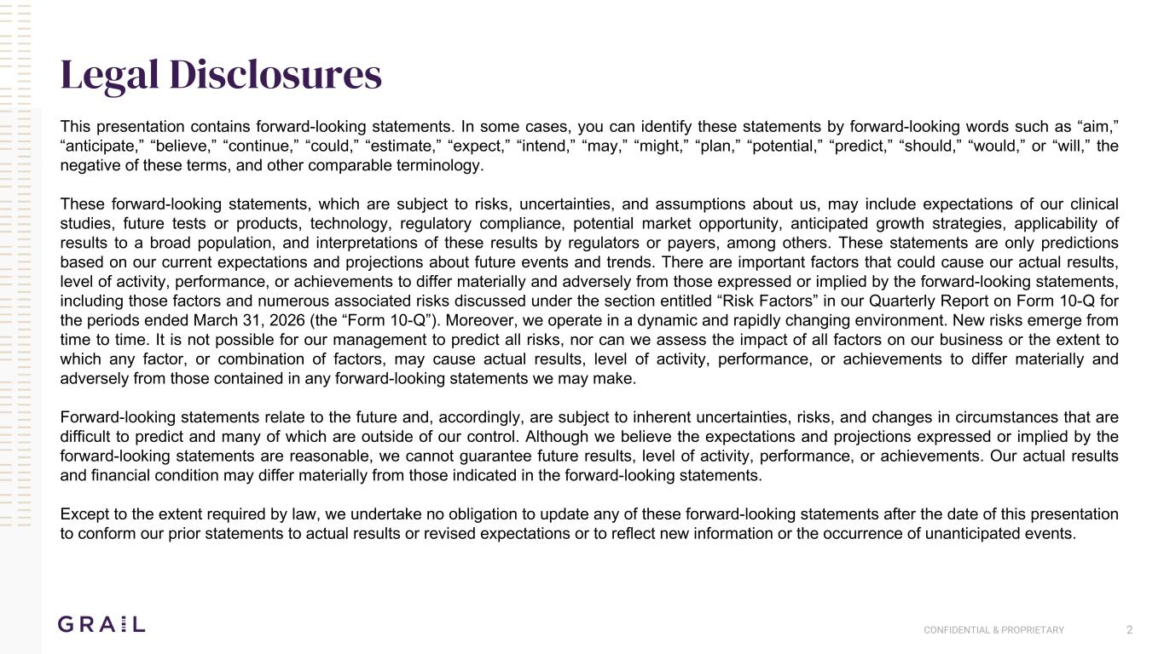
CONFIDENTIAL & PROPRIETARY 2 Legal Disclosures This presentation contains forward-looking statements. In some cases, you can identify these statements by forward-looking words such as “aim,” “anticipate,” “believe,” “continue,” “could,” “estimate,” “expect,” “intend,” “may,” “might,” “plan,” “potential,” “predict,” “should,” “would,” or “will,” the negative of these terms, and other comparable terminology. These forward-looking statements, which are subject to risks, uncertainties, and assumptions about us, may include expectations of our clinical studies, future tests or products, technology, regulatory compliance, potential market opportunity, anticipated growth strategies, applicability of results to a broad population, and interpretations of these results by regulators or payers, among others. These statements are only predictions based on our current expectations and projections about future events and trends. There are important factors that could cause our actual results, level of activity, performance, or achievements to differ materially and adversely from those expressed or implied by the forward-looking statements, including those factors and numerous associated risks discussed under the section entitled “Risk Factors” in our Quarterly Report on Form 10-Q for the periods ended March 31, 2026 (the “Form 10-Q”). Moreover, we operate in a dynamic and rapidly changing environment. New risks emerge from time to time. It is not possible for our management to predict all risks, nor can we assess the impact of all factors on our business or the extent to which any factor, or combination of factors, may cause actual results, level of activity, performance, or achievements to differ materially and adversely from those contained in any forward-looking statements we may make. Forward-looking statements relate to the future and, accordingly, are subject to inherent uncertainties, risks, and changes in circumstances that are difficult to predict and many of which are outside of our control. Although we believe the expectations and projections expressed or implied by the forward-looking statements are reasonable, we cannot guarantee future results, level of activity, performance, or achievements. Our actual results and financial condition may differ materially from those indicated in the forward-looking statements. Except to the extent required by law, we undertake no obligation to update any of these forward-looking statements after the date of this presentation to conform our prior statements to actual results or revised expectations or to reflect new information or the occurrence of unanticipated events.

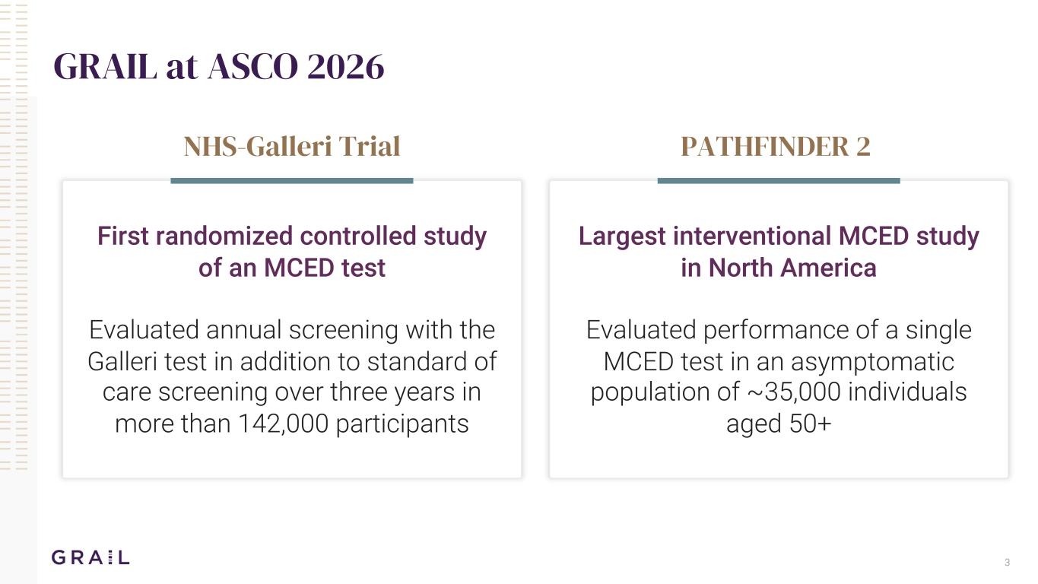
3 GRAIL at ASCO 2026 NHS-Galleri Trial PATHFINDER 2 First randomized controlled study of an MCED test Evaluated annual screening with the Galleri test in addition to standard of care screening over three years in more than 142,000 participants Largest interventional MCED study in North America Evaluated performance of a single MCED test in an asymptomatic population of ~35,000 individuals aged 50+


NHS-Galleri 4

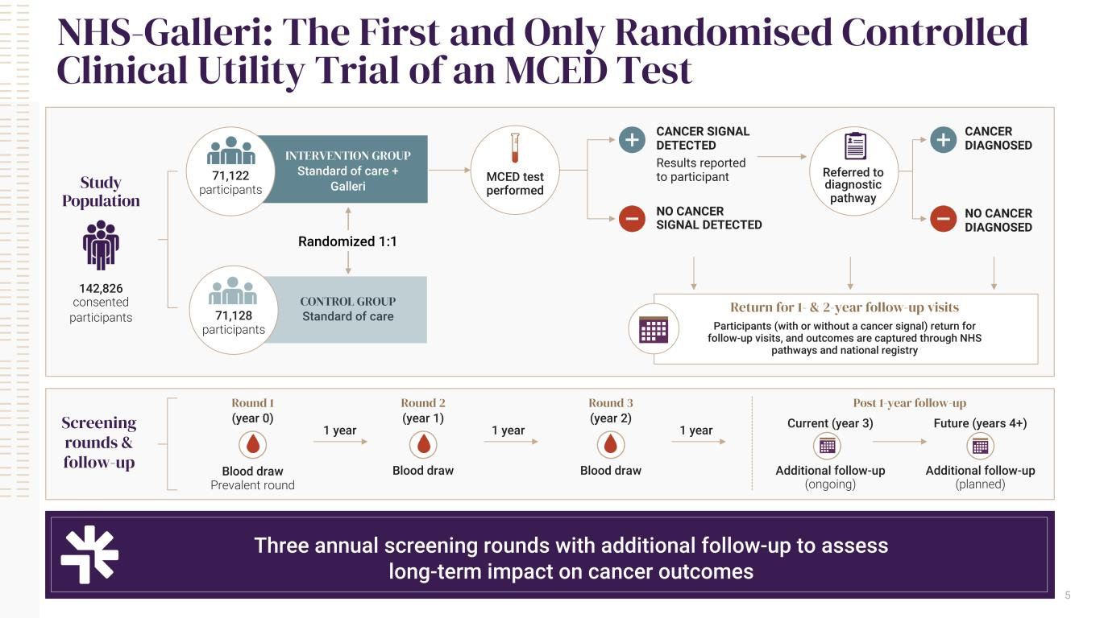
CONTROL GROUP Standard of care Three annual screening rounds with additional follow-up to assess long-term impact on cancer outcomes 5 NHS-Galleri: The First and Only Randomised Controlled Clinical Utility Trial of an MCED Test Study Population 142,826 consented participants INTERVENTION GROUP Standard of care + Galleri Randomized 1:1 CANCER SIGNAL DETECTED Results reported to participant NO CANCER SIGNAL DETECTED Screening rounds & follow-up Round 1 (year 0) Round 2 (year 1) Round 3 (year 2) Post 1-year follow-up Blood draw Prevalent round Blood draw Blood draw Additional follow-up (ongoing) Additional follow-up (planned) Current (year 3) Future (years 4+)1 year 1 year 1 year 71,122 participants 71,128 participants MCED test performed Referred to diagnostic pathway CANCER DIAGNOSED NO CANCER DIAGNOSED Return for 1- & 2-year follow-up visits Participants (with or without a cancer signal) return for follow-up visits, and outcomes are captured through NHS pathways and national registry

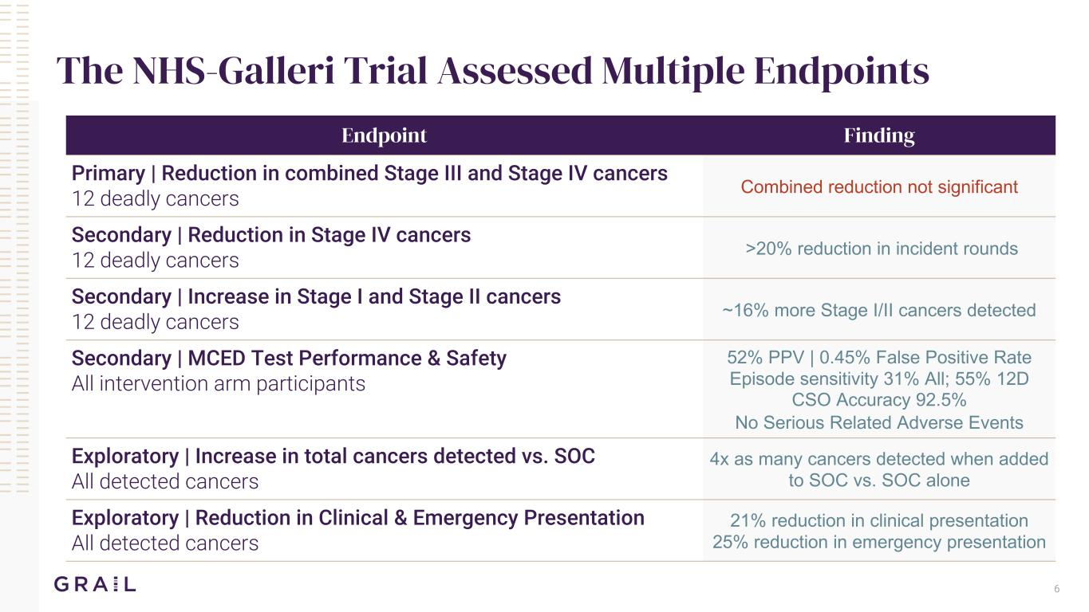
Endpoint Finding Primary | Reduction in combined Stage III and Stage IV cancers 12 deadly cancers Combined reduction not significant Secondary | Reduction in Stage IV cancers 12 deadly cancers >20% reduction in incident rounds Secondary | Increase in Stage I and Stage II cancers 12 deadly cancers ~16% more Stage I/II cancers detected Secondary | MCED Test Performance & Safety All intervention arm participants 52% PPV | 0.45% False Positive Rate Episode sensitivity 31% All; 55% 12D CSO Accuracy 92.5% No Serious Related Adverse Events Exploratory | Increase in total cancers detected vs. SOC All detected cancers 4x as many cancers detected when added to SOC vs. SOC alone Exploratory | Reduction in Clinical & Emergency Presentation All detected cancers 21% reduction in clinical presentation 25% reduction in emergency presentation The NHS-Galleri Trial Assessed Multiple Endpoints 6

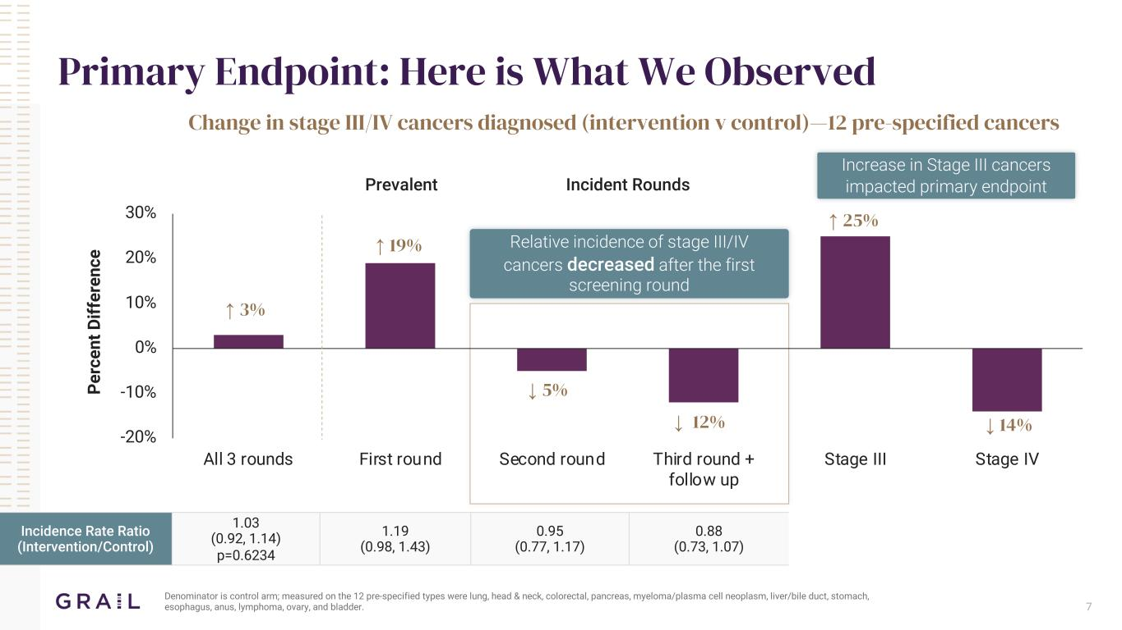
-20% -10% 0% 10% 20% 30% All 3 rounds First round Second round Third round + follow up Stage III Stage IV 7 Primary Endpoint: Here is What We Observed Denominator is control arm; measured on the 12 pre-specified types were lung, head & neck, colorectal, pancreas, myeloma/plasma cell neoplasm, liver/bile duct, stomach, esophagus, anus, lymphoma, ovary, and bladder. Change in stage III/IV cancers diagnosed (intervention v control)—12 pre-specified cancers Prevalent Incident Rounds Incidence Rate Ratio (Intervention/Control) 1.03 (0.92, 1.14) p=0.6234 1.19 (0.98, 1.43) 0.95 (0.77, 1.17) 0.88 (0.73, 1.07) Pe rc en t D iff er en ce ↑ 3% ↑ 19% ↓ 5% ↓ 12% Relative incidence of stage III/IV cancers decreased after the first screening round Increase in Stage III cancers impacted primary endpoint ↓ 14% ↑ 25%

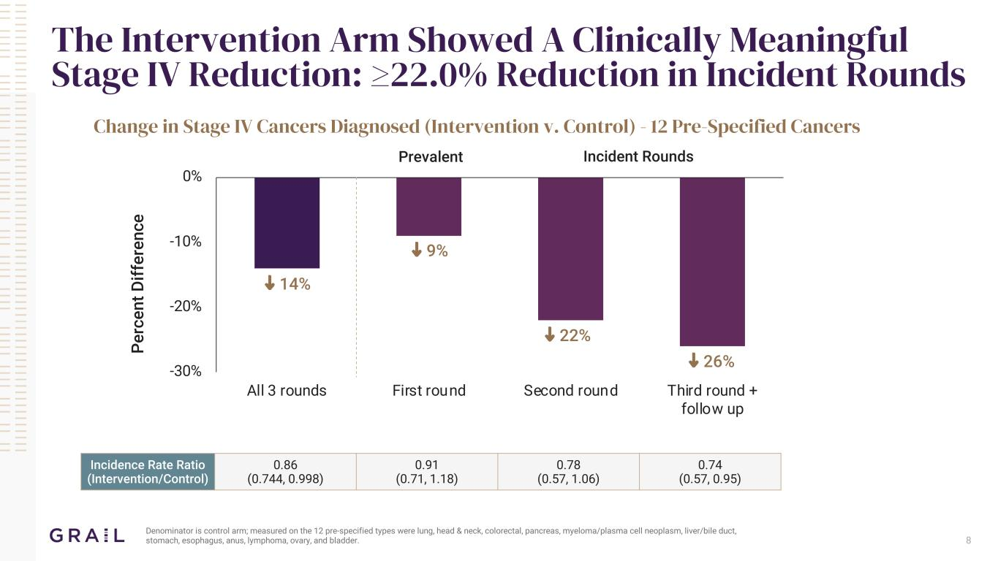
The Intervention Arm Showed A Clinically Meaningful Stage IV Reduction: ≥22.0% Reduction in Incident Rounds Denominator is control arm; measured on the 12 pre-specified types were lung, head & neck, colorectal, pancreas, myeloma/plasma cell neoplasm, liver/bile duct, stomach, esophagus, anus, lymphoma, ovary, and bladder. -30% -20% -10% 0% All 3 rounds First round Second round Third round + follow up ↓ 26% ↓ 22% ↓ 9% ↓ 14% Change in Stage IV Cancers Diagnosed (Intervention v. Control) - 12 Pre-Specified Cancers Prevalent Incident Rounds Incidence Rate Ratio (Intervention/Control) 0.86 (0.744, 0.998) 0.91 (0.71, 1.18) 0.78 (0.57, 1.06) 0.74 (0.57, 0.95) 8 Pe rc en t D iff er en ce

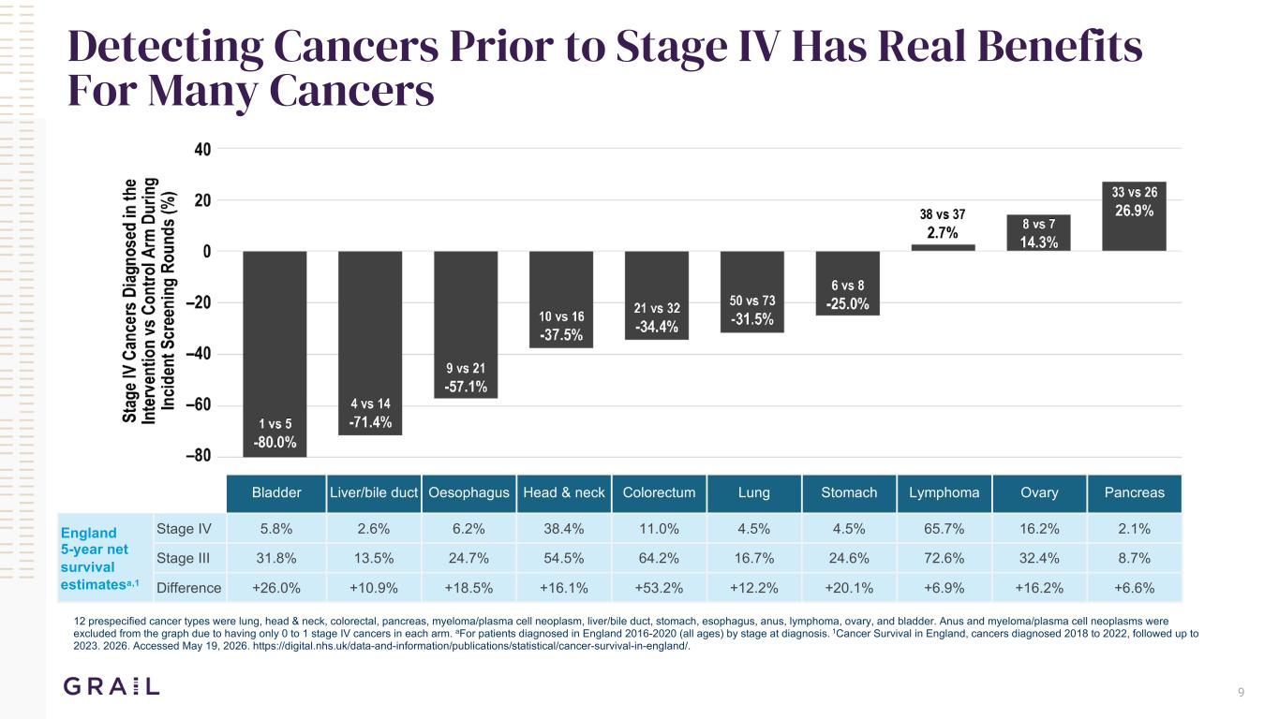
9 Detecting Cancers Prior to Stage IV Has Real Benefits For Many Cancers 12 prespecified cancer types were lung, head & neck, colorectal, pancreas, myeloma/plasma cell neoplasm, liver/bile duct, stomach, esophagus, anus, lymphoma, ovary, and bladder. Anus and myeloma/plasma cell neoplasms were excluded from the graph due to having only 0 to 1 stage IV cancers in each arm. aFor patients diagnosed in England 2016-2020 (all ages) by stage at diagnosis. 1Cancer Survival in England, cancers diagnosed 2018 to 2022, followed up to 2023. 2026. Accessed May 19, 2026. https://digital.nhs.uk/data-and-information/publications/statistical/cancer-survival-in-england/. Bladder Liver/bile duct Oesophagus Head & neck Colorectum Lung Stomach Lymphoma Ovary Pancreas England 5-year net survival estimatesa,1 Stage IV 5.8% 2.6% 6.2% 38.4% 11.0% 4.5% 4.5% 65.7% 16.2% 2.1% Stage III 31.8% 13.5% 24.7% 54.5% 64.2% 16.7% 24.6% 72.6% 32.4% 8.7% Difference +26.0% +10.9% +18.5% +16.1% +53.2% +12.2% +20.1% +6.9% +16.2% +6.6%

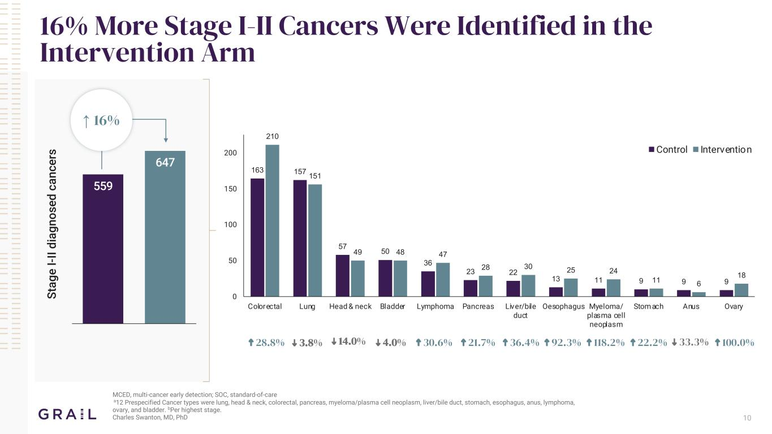
163 157 57 50 36 23 22 13 11 9 9 9 210 151 49 48 47 28 30 25 24 11 6 18 0 50 100 150 200 Colorectal Lung Head & neck Bladder Lymphoma Pancreas Liver/bile duct Oesophagus Myeloma/ plasma cell neoplasm Stom ach Anus Ovary Control Intervention 10 16% More Stage I-II Cancers Were Identified in the Intervention Arm MCED, multi-cancer early detection; SOC, standard-of-care a12 Prespecified Cancer types were lung, head & neck, colorectal, pancreas, myeloma/plasma cell neoplasm, liver/bile duct, stomach, esophagus, anus, lymphoma, ovary, and bladder. bPer highest stage. Charles Swanton, MD, PhD 559 647 559/1298 (43.1%) 647/1421 (45.3%) St ag e I-I I d ia gn os ed c an ce rs ↑ 16% ↑ 28.8% ↑ 30.6% ↑ 21.7% ↑ 36.4% ↑ 92.3% ↑ 118.2% ↑ 22.2% ↑ 100.0% ↓ 3.8% ↓ 14.0% ↓ 4.0% ↓ 33.3%

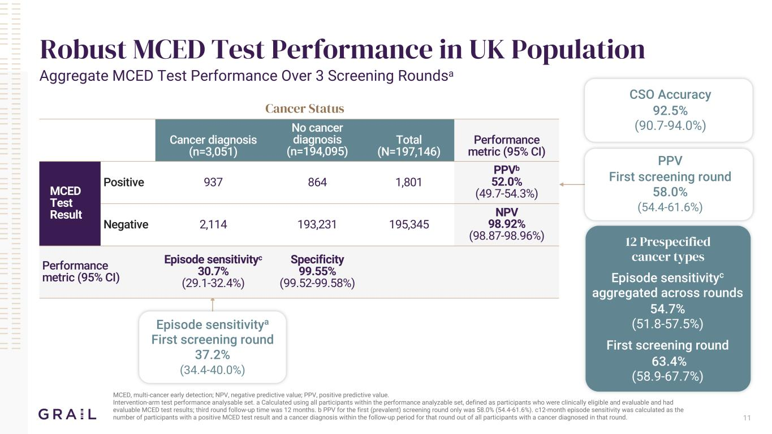
Cancer Status Cancer diagnosis (n=3,051) No cancer diagnosis (n=194,095) Total (N=197,146) Performance metric (95% CI) MCED Test Result Positive 937 864 1,801 PPVb 52.0% (49.7-54.3%) Negative 2,114 193,231 195,345 NPV 98.92% (98.87-98.96%) Performance metric (95% CI) Episode sensitivityc 30.7% (29.1-32.4%) Specificity 99.55% (99.52-99.58%) MCED, multi-cancer early detection; NPV, negative predictive value; PPV, positive predictive value. Intervention-arm test performance analysable set. a Calculated using all participants within the performance analyzable set, defined as participants who were clinically eligible and evaluable and had evaluable MCED test results; third round follow-up time was 12 months. b PPV for the first (prevalent) screening round only was 58.0% (54.4-61.6%). c12-month episode sensitivity was calculated as the number of participants with a positive MCED test result and a cancer diagnosis within the follow-up period for that round out of all participants with a cancer diagnosed in that round. Robust MCED Test Performance in UK Population Aggregate MCED Test Performance Over 3 Screening Roundsa CSO Accuracy 92.5% (90.7-94.0%) Episode sensitivityc aggregated across rounds 54.7% (51.8-57.5%) First screening round 63.4% (58.9-67.7%) Episode sensitivitya First screening round 37.2% (34.4-40.0%) 12 Prespecified cancer types PPV First screening round 58.0% (54.4-61.6%) 11

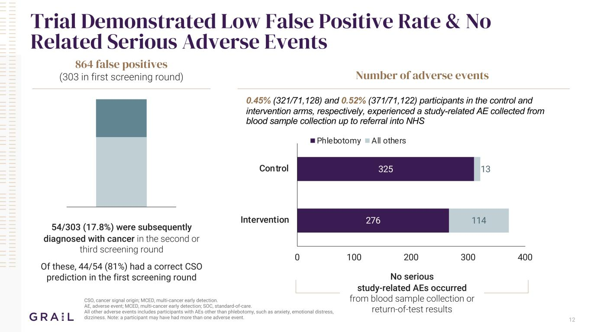
12 Trial Demonstrated Low False Positive Rate & No Related Serious Adverse Events 864 false positives (303 in first screening round) 54/303 (17.8%) were subsequently diagnosed with cancer in the second or third screening round Of these, 44/54 (81%) had a correct CSO prediction in the first screening round CSO, cancer signal origin; MCED, multi-cancer early detection. AE, adverse event; MCED, multi-cancer early detection; SOC, standard-of-care. All other adverse events includes participants with AEs other than phlebotomy, such as anxiety, emotional distress, dizziness. Note: a participant may have had more than one adverse event. Number of adverse events 276 325 114 13 0 100 200 300 400 Intervention Control Phlebotomy All others No serious study-related AEs occurred from blood sample collection or return-of-test results 0.45% (321/71,128) and 0.52% (371/71,122) participants in the control and intervention arms, respectively, experienced a study-related AE collected from blood sample collection up to referral into NHS

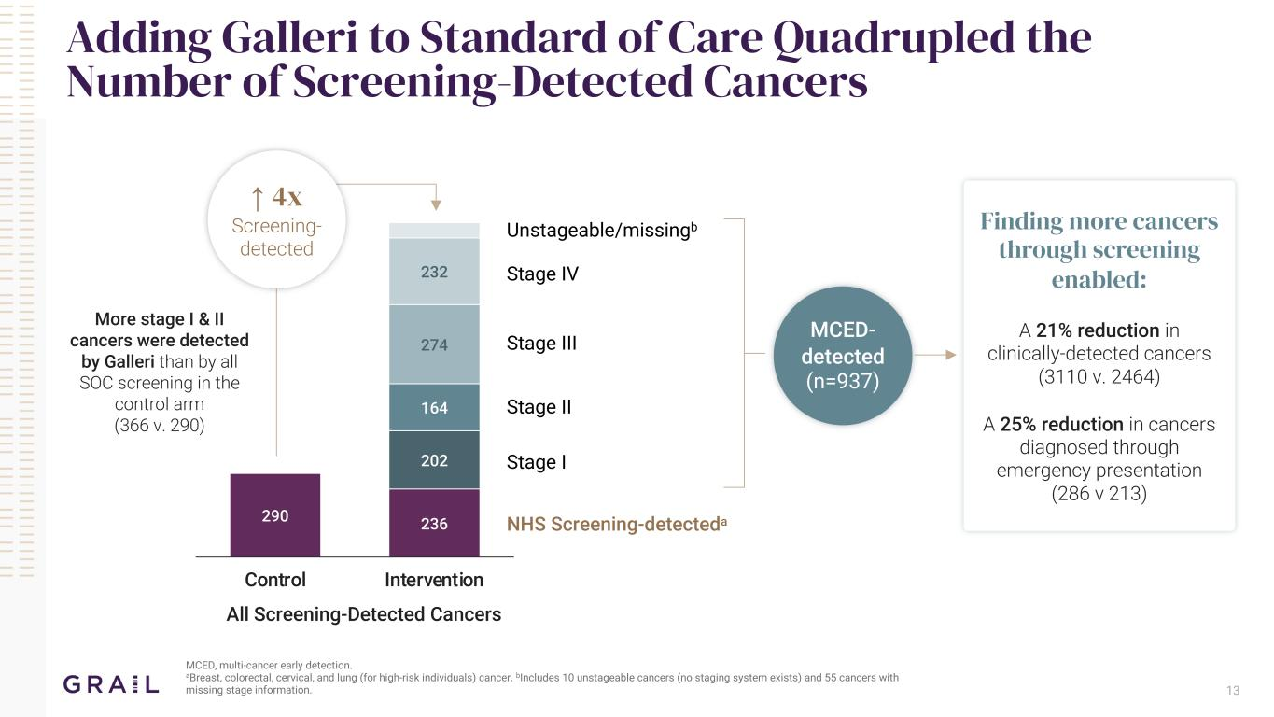
13 Adding Galleri to Standard of Care Quadrupled the Number of Screening-Detected Cancers MCED, multi-cancer early detection. aBreast, colorectal, cervical, and lung (for high-risk individuals) cancer. bIncludes 10 unstageable cancers (no staging system exists) and 55 cancers with missing stage information. 290 236 202 164 274 232 Control Intervention ↑ 4x Screening- detected Unstageable/missingb Stage IV Stage III Stage II Stage I NHS Screening-detecteda MCED- detected (n=937) More stage I & II cancers were detected by Galleri than by all SOC screening in the control arm (366 v. 290) Finding more cancers through screening enabled: A 21% reduction in clinically-detected cancers (3110 v. 2464) A 25% reduction in cancers diagnosed through emergency presentation (286 v 213) All Screening-Detected Cancers

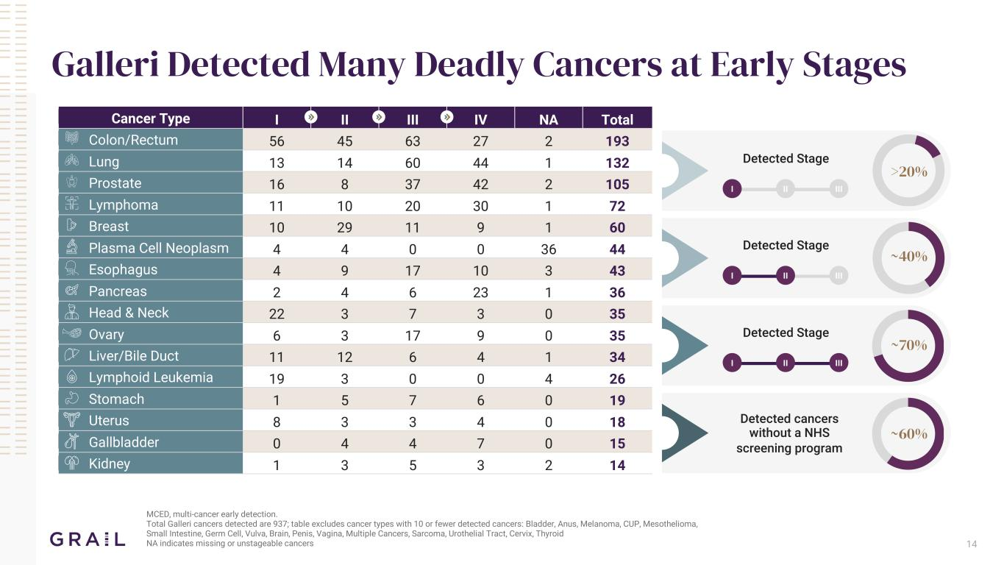
14 Galleri Detected Many Deadly Cancers at Early Stages MCED, multi-cancer early detection. Total Galleri cancers detected are 937; table excludes cancer types with 10 or fewer detected cancers: Bladder, Anus, Melanoma, CUP, Mesothelioma, Small Intestine, Germ Cell, Vulva, Brain, Penis, Vagina, Multiple Cancers, Sarcoma, Urothelial Tract, Cervix, Thyroid NA indicates missing or unstageable cancers Cancer Type I II III IV NA Total Colon/Rectum 56 45 63 27 2 193 Lung 13 14 60 44 1 132 Prostate 16 8 37 42 2 105 Lymphoma 11 10 20 30 1 72 Breast 10 29 11 9 1 60 Plasma Cell Neoplasm 4 4 0 0 36 44 Esophagus 4 9 17 10 3 43 Pancreas 2 4 6 23 1 36 Head & Neck 22 3 7 3 0 35 Ovary 6 3 17 9 0 35 Liver/Bile Duct 11 12 6 4 1 34 Lymphoid Leukemia 19 3 0 0 4 26 Stomach 1 5 7 6 0 19 Uterus 8 3 3 4 0 18 Gallbladder 0 4 4 7 0 15 Kidney 1 3 5 3 2 14 >20% ~40% ~70% Detected Stage I II III Detected Stage I II III Detected Stage I II III Detected cancers without a NHS screening program ~60%

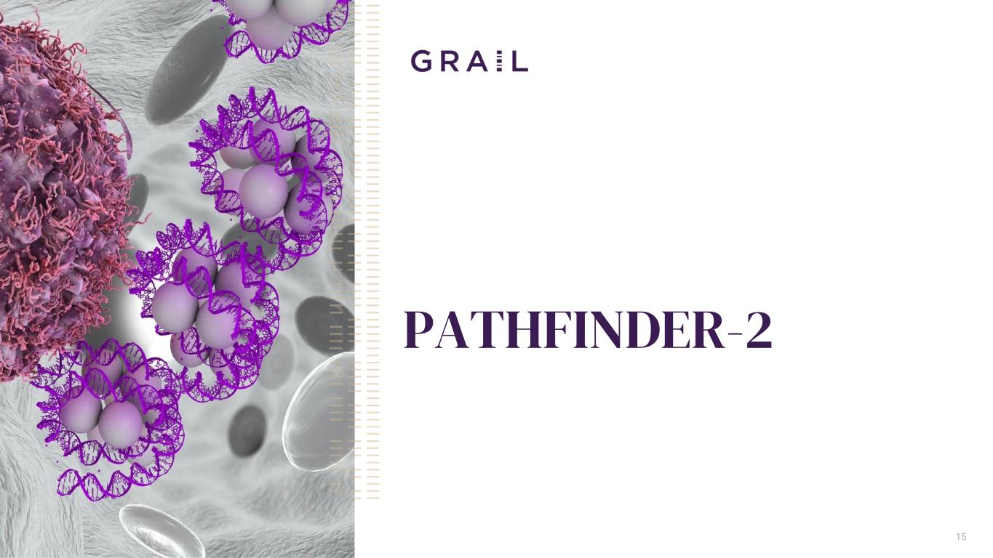
PATHFINDER-2 15

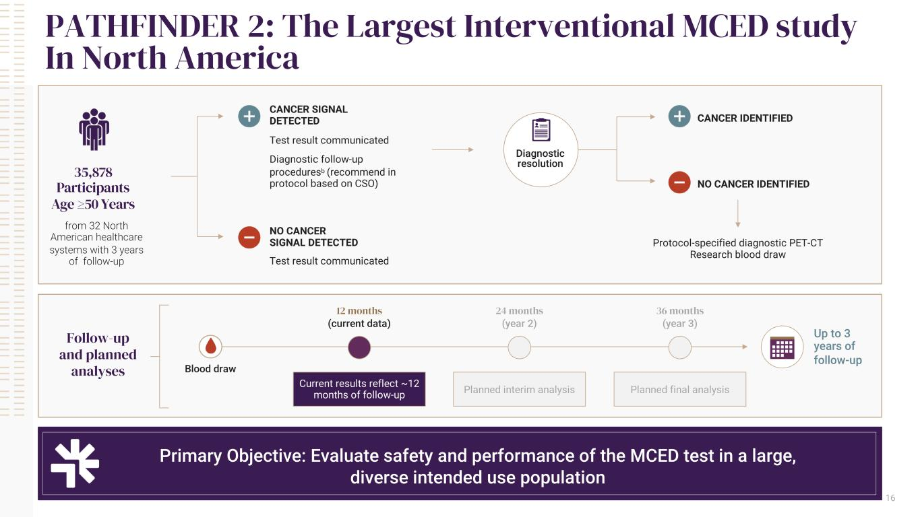
16 PATHFINDER 2: The Largest Interventional MCED study In North America Primary Objective: Evaluate safety and performance of the MCED test in a large, diverse intended use population 35,878 Participants Age ≥50 Years from 32 North American healthcare systems with 3 years of follow-up CANCER SIGNAL DETECTED Test result communicated Diagnostic follow-up proceduresb (recommend in protocol based on CSO) NO CANCER SIGNAL DETECTED Follow-up and planned analyses 12 months (current data) Blood draw Diagnostic resolution CANCER IDENTIFIED NO CANCER IDENTIFIED Test result communicated Protocol-specified diagnostic PET-CT Research blood draw Current results reflect ~12 months of follow-up 24 months (year 2) Planned interim analysis 36 months (year 3) Planned final analysis Up to 3 years of follow-up

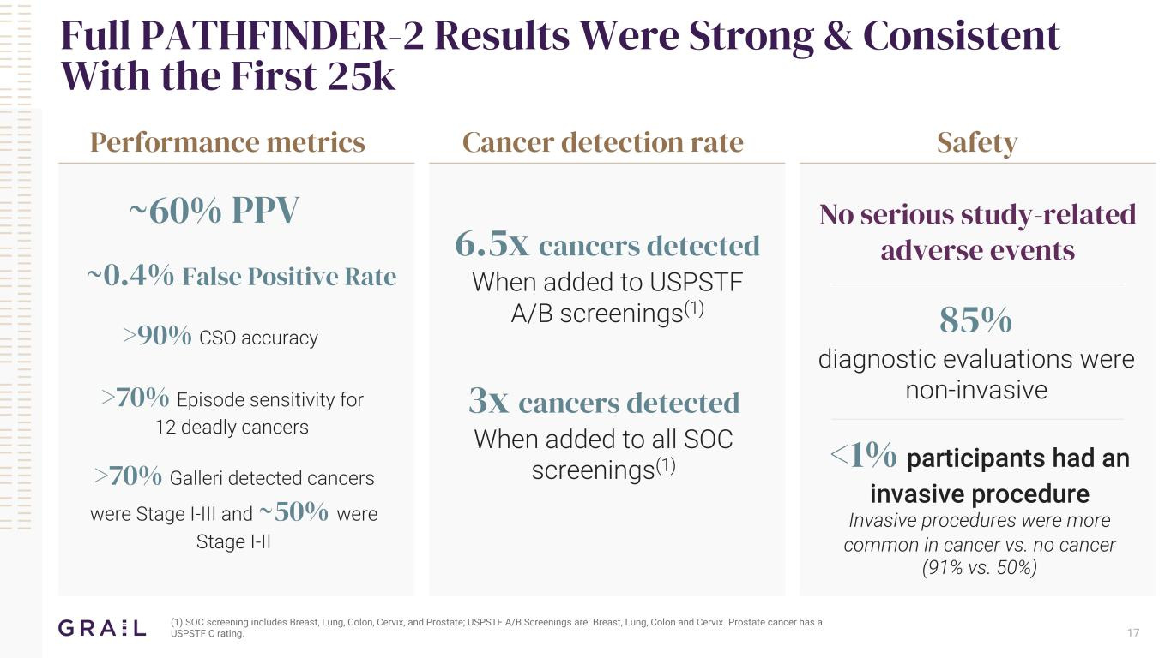
Full PATHFINDER-2 Results Were Strong & Consistent With the First 25k 17 Performance metrics Cancer detection rate Safety ~60% PPV ~0.4% False Positive Rate >90% CSO accuracy >70% Episode sensitivity for 12 deadly cancers 6.5x cancers detected When added to USPSTF A/B screenings(1) 3x cancers detected When added to all SOC screenings(1) No serious study-related adverse events 85% diagnostic evaluations were non-invasive <1% participants had an invasive procedure Invasive procedures were more common in cancer vs. no cancer (91% vs. 50%) >70% Galleri detected cancers were Stage I-III and ~50% were Stage I-II (1) SOC screening includes Breast, Lung, Colon, Cervix, and Prostate; USPSTF A/B Screenings are: Breast, Lung, Colon and Cervix. Prostate cancer has a USPSTF C rating.


Summary 18

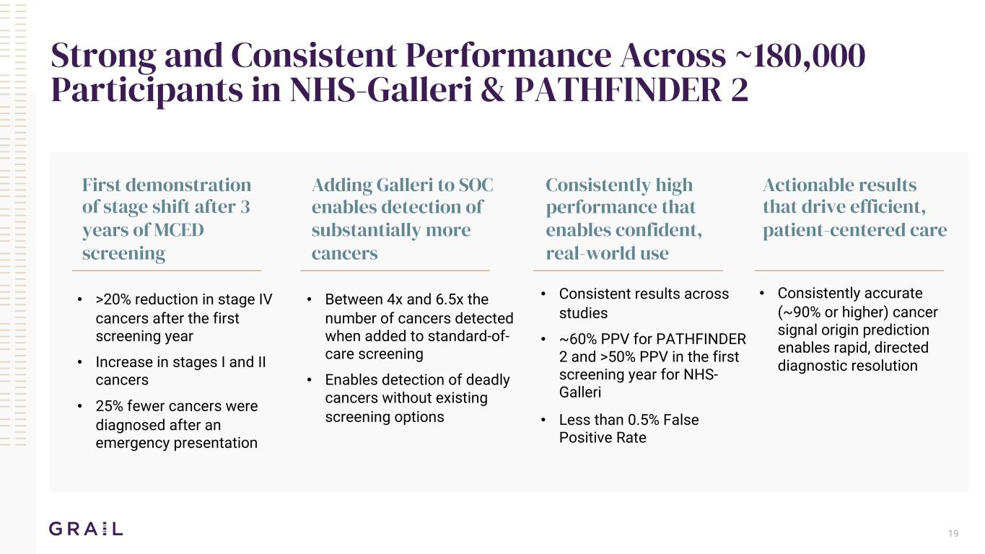
Strong and Consistent Performance Across ~180,000 Participants in NHS-Galleri & PATHFINDER 2 First demonstration of stage shift after 3 years of MCED screening • >20% reduction in stage IV cancers after the first screening year • Increase in stages I and II cancers • 25% fewer cancers were diagnosed after an emergency presentation Adding Galleri to SOC enables detection of substantially more cancers Consistently high performance that enables confident, real-world use Actionable results that drive efficient, patient-centered care • Between 4x and 6.5x the number of cancers detected when added to standard-of- care screening • Enables detection of deadly cancers without existing screening options • Consistent results across studies • ~60% PPV for PATHFINDER 2 and >50% PPV in the first screening year for NHS- Galleri • Less than 0.5% False Positive Rate • Consistently accurate (~90% or higher) cancer signal origin prediction enables rapid, directed diagnostic resolution 19

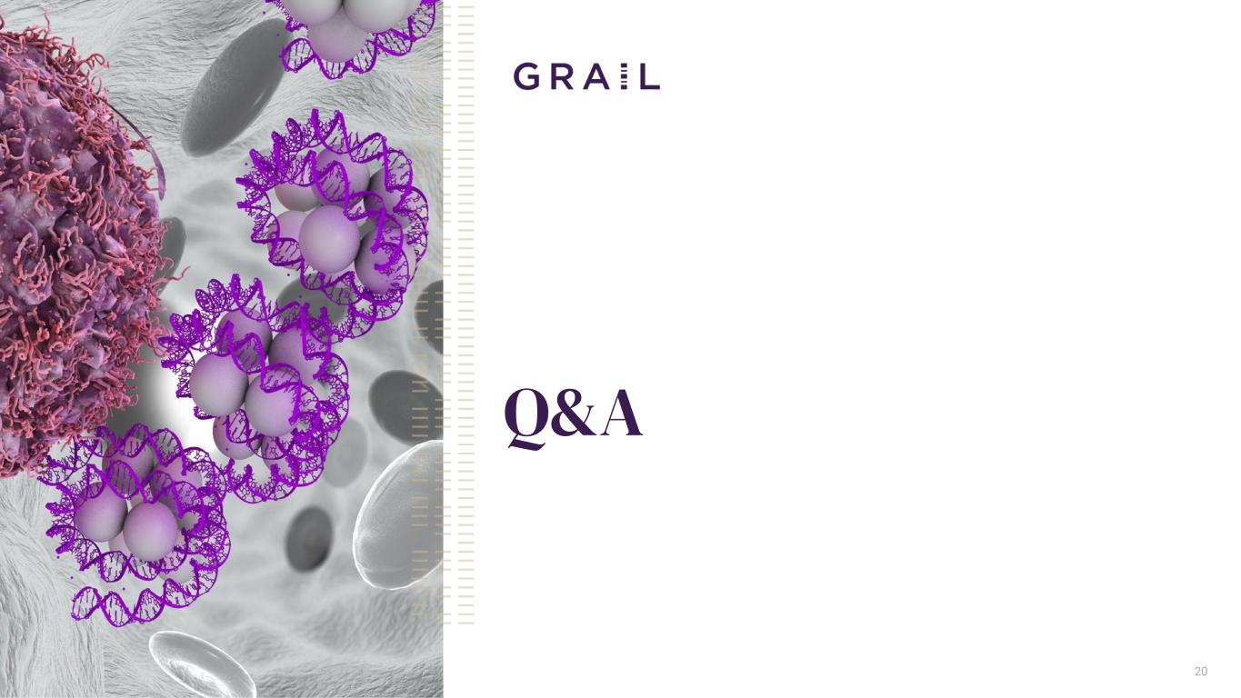
Q&A 20

